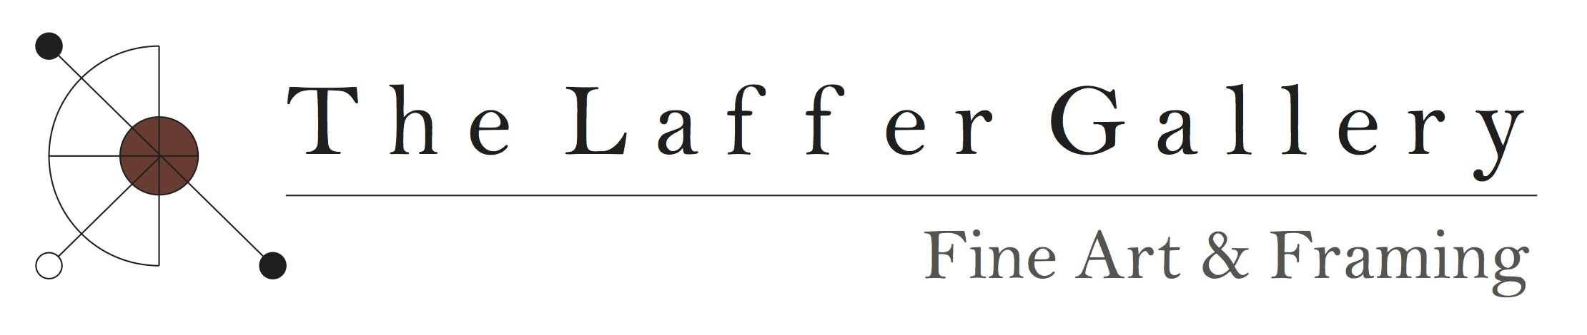

EXHIBITIONS
______________________________________________________________________________
Open Studio Tour of Washington County - Founding participant/bi-annual since 2007
Saratoga Arts Center, Saratoga Springs, NY Two Person Show - 2015
Artisan’s Market - Small Gallery, Cambridge NY Solo Exhibit - 2014
ASA Landscapes for Land’s Sake, Cambridge, NY Group Exhibit - 2014-2015
Southern Vermont Arts Center, Manchester, VT Solo Exhibit - 2014
Southern Vermont Arts Center, Manchester, VT Group Exhibit - 2009 thru 2015
Saratoga Arts Center, Saratoga Springs, NY Group Exhibits - 2012/2013
Gallery 668, Cambridge, NY Group Exhibit - 2012
House of Creative Soul, Saratoga Springs, NY Group Exhibit - 2010/2011
Riverfront Studios Gallery - Schuylerville, NY Group Exhibit - 2011/2012
80 Washington Square East Galleries - New York, NY Group Exhibit - 2008
Riverfront Studios Gallery - Schuylerville, NY 5-Person Exhibit - 2010
Saratoga Amtrak Station Gallery, Saratoga Springs, NY 3-Person Exhibit - 2006
Riverfront Studios Gallery - Schuylerville, NY 4-Person Exhibit - 2006
Valley Artisan's Market/Small Gallery - Cambridge, NY Group Exhibit - 2004
Maple Ridge Gallery - Cambridge, NY Group Exhibit - 2003/2005
Berkshire Artisans, Lichtenstein Center for the Arts - Pittsfield, MA 2-Person Exhibit - 2002
Lapham Gallery - LARAC Glens Falls, NY 4-Person Exhibit - 2002
New York University-Broadway Windows Gallery New York, NY Solo Exhibit - 2001
The Arts Center Gallery-S.C.A.C. Saratoga Springs, NY - 2-Person Exhibit - 2000
Northeast Regional - Schenectady Museum - Group Exhibit - 2000
Valley Artisan’s Market/Small Gallery - Cambridge, NY - Solo Exhibit - 1999
Art Fair ‘98 - Schenectady Museum, Schenectady, NY - Group Exhibit - 1998

