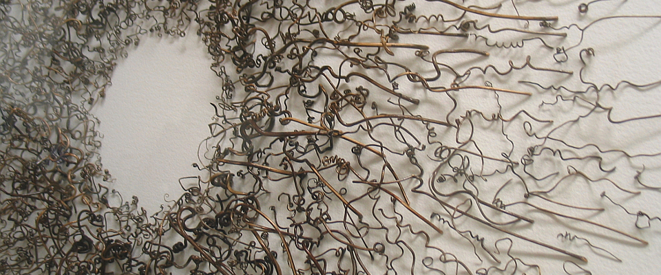

Russell Serrianne

Solo Exhibitions
2015 | Russell Serrianne – Natural Line, Christine Price Gallery, Castleton State College, Castleton, VT
2013 | Russell Serrianne, Cary House Gallery – Salem Art Works, Salem, NY
2011 | Russell Serrianne: Vine Tendrils – Assemblage & Drawings, Gallery 7444, Saranac Lake, NY

Installations
2006 | The Zoetrope Project, SUNY Adirondack, Queensbury, NY • Outdoor zoetrope installation

Selected Group/Juried Exhibitions
2016 Made in NY 2016, Schweinfurth Memorial Art Center, Auburn, NY
Mohawk Hudson Regional 2016, Hyde Collection, Glens Falls, NY
Texture, Depth & Color - Russell Serrianne & Harry Orlyk, Giant Mountain Studio Gallery, Schroon Lake,
Brandt, Serrianne, Von Rosk & Tompson, Shirt Factory Gallery, Glens Falls, NY
2015 | Fiber Currents, Parrella Gallery, Fulton Montgomery Community College, Johnstown, NY 2015 Upstate Artists, Laffer Gallery, Schuylerville, NY 2015 Russell Serrianne & Barry Lobdell, Lake Placid Center for the Arts, Lake Placid, NY
2014 | Upstate Artists, Laffer Gallery, Schuylerville, NY
2014 | Ariana Kolins and Russell Serrianne, Courthouse Gallery, Lake George Arts Project, Lake George, NY
2014 | Arts Attitudes 2014, Malta League of Arts, Round Lake, NY
2014 | 2014 Adirondack Juried Show, Lake Placid Center for the Arts, Lake Placid, NY
2013 | Small Works, Shirt Factory Gallery, Glens Falls, NY (Best of Show Award)
2013 | 2013 The Fence Select, The Arts Center of the Capital District, Troy, NY
2013 | Textures and Patterns, Lower Adirondack Regional Arts Council, Glens Falls, NY
2013 | Upstate Artists, Laffer Gallery, Schuylerville, NY
2012 | Japanese Influence – Layer and Line; Cannamela, Serrianne & Silvious, Albany Center Gallery, Albany
2012 | Made in NY 2012, Schweinfurth Memorial Art Center, Auburn, NY
2012 | Art @ the Lake, Lake George Arts Project, Lake George, NY
2012 | Palestri, Serrianne and Segan,Crandall Public Library, Glens Falls, NY
2012 | Upstate Artists, Laffer Gallery, Schuylerville, NY
2011 | Henderson – Serrianne – Longhurst, Vantage Gallery, Glens Falls, NY
2011 | Art @ the Lake, Lake George Arts Project, Bolton Landing, NY
2011 | Paper Works – McDaniel, Renfro, Rink & Serrianne, Lower Adirondack Regional Arts Council, Glens Falls, NY
2010 | Russell Serrianne and John Hampshire – New Works, Ivy Associates Gallery, Schuylerville, NY
2010 | Art in Public Places Exhibition, Saratoga Arts Center, Saratoga Springs, NY
2009 | Five Artists, Myott Gallery, Glens Falls, NY
2008 | Lower Adirondack Regional Arts Council, Glens Falls, NY
2008 | Invitational – The Shirt Factory Artists, North Main Gallery, Salem, NY

Grants
2006 | Recipient New York State Council on the Arts Artist Grant

